**CS 151 Exercise One**

Name: Angeline Lee

Repository access link: <https://github.com/angelinelee22/CS-151>

Instructions:

1. Compile the program with javac ExerciseOne.java
2. Run with java ExerciseOne

* I compiled it in the folder, which is why the ExerciseOne.class is already present, so you can just run that.

Screenshot:

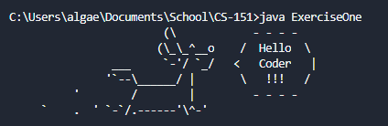

Citations:

<https://asciiart.website//index.php?art=animals/dogs>